What is Naviance Student?

BIG news. This Summer, Naviance Student replaced Family Connection…

The new Naviance Student portal is mobile-friendly, simple, and intuitive. The best part is– all the features you know and love from Family Connection?– yep, they’re still there. As an added bonus, we’ve even added a few enhanced features.
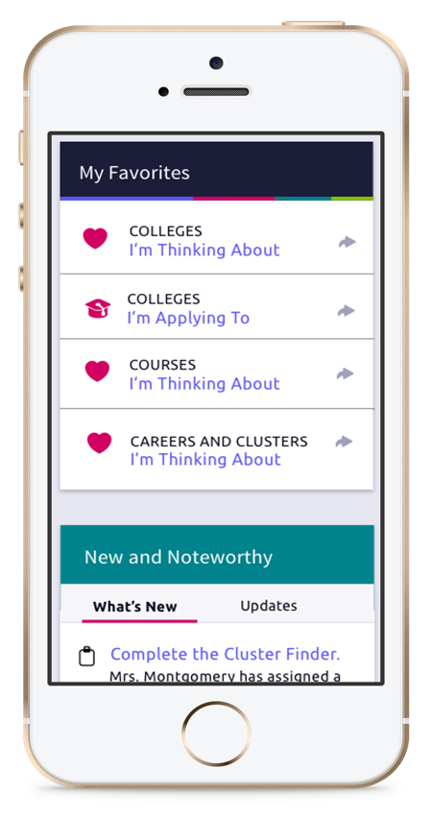

New Layout

Enjoy a new refreshed desktop experience

Clean and simplified layout with a familiar workflow navigation

New home page

It is easier than ever for you to find relevant information and take action, especially thanks to the new search bar

Got a phone? On the Go?

Take Naviance with you! You can now access Naviance Student on your smartphone, tablet, laptop, or desktop

New Functionality
- Let Naviance play (college) matchmaker
Check out 20 new SuperMatch filters and more institute user interface to find your best fit colleges
- Did we mention it is easier to use?
View progress on assessments and surveys, export your resume in printer-friendly formats. And view a calendar of your upcoming to-dos and tasks

What’s Next?
Check out what Naviance Student has to offer by using your device’s internet browser. [School Name’s] Naviance Student platform can be accessed using the following address:
  - https://student.naviance.com/schoolalias

